THE REAL SCHOOLS
LEARNER’S EMPOWERMENT ACTIVITY
P.5 MATHEMATICS
SET CONCEPTS
TERM ONE 2025

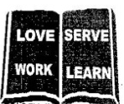
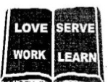
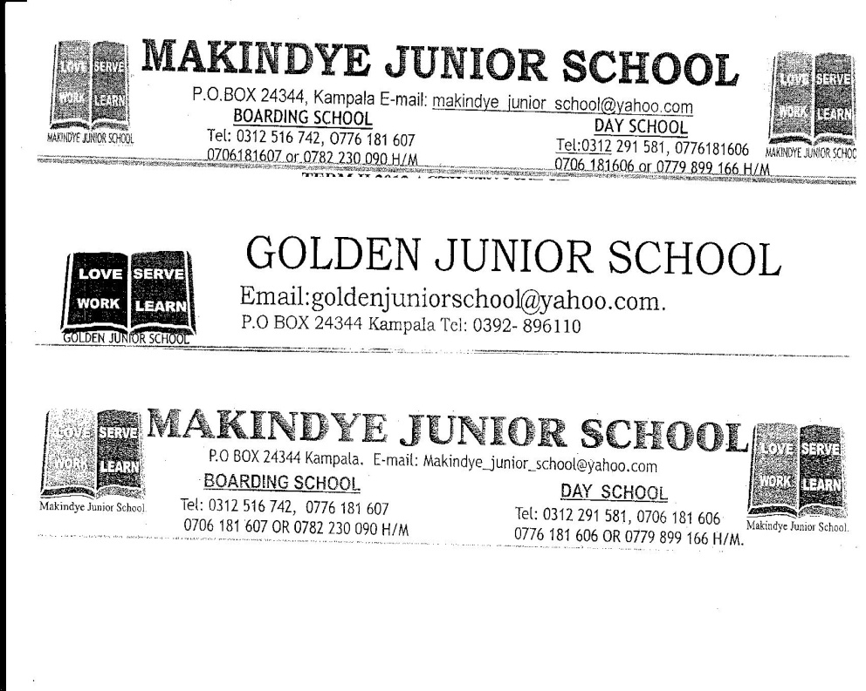

Victoria P/S

Golden Junior
School

Makindye Junior School

An excellent first grade and excellent character for every pupil

NAME……………………………………………………………………CLASS: ………………………………
SCHOOL: ……………………………………………………………………………………………………………..
TOPIC: SET CONCEPTS
SESSION NUMBER 1
Background knowledge: as a learner, you must be having knowledge on the following.
- Listing elements
- Finding number of elements.
- Describing sets//
- Identifying symbols related to types of sets
- Key learning principle on session competences include.
Equivalent sets ( ) (have same number of elements.)
Equal sets (=)
Un equal sets
Empty sets ( ) or { }
- Relevancy
This topic equips you with computation skills, grouping and identifying elements basing on colour and type.
- LESSON 1
- Describing equivalent and non equivalent stes.
- Describing equal and un equal stes.
- Describing empty sets/ null sets or void sets
- Describing intersection sets.
- Key learning principle
-Equivalent sets have the same number of elements
-Nonequivalent sets are sets with different number of elements.
-Un equal sets have different number of elements but of the same kind.
-Empty sets are sets with no elements.

- Equivalent and non-equivalent sets.
Examples
1. | Given that set P = {a, b, c, d, e, f, n} and set Q = {w, a, p, c, x, d}. describe sets P and Q  n(Q) = 7  n(P) = n(Q) = 7.  Set P and Q are equivalent sets. | 2. | If set R ={even numbers less than 15} and sets S={5, 10, 7, 0, e, 12, 6}  a) List set R  R = {0, 2, 4, 6, 8, 10, 10, 12, 14}
b) Find the relationship between set R and S
n(R) = 8
n(S) = 7
set R and S are non-equivalent sets.
 | Practice activity
1. | 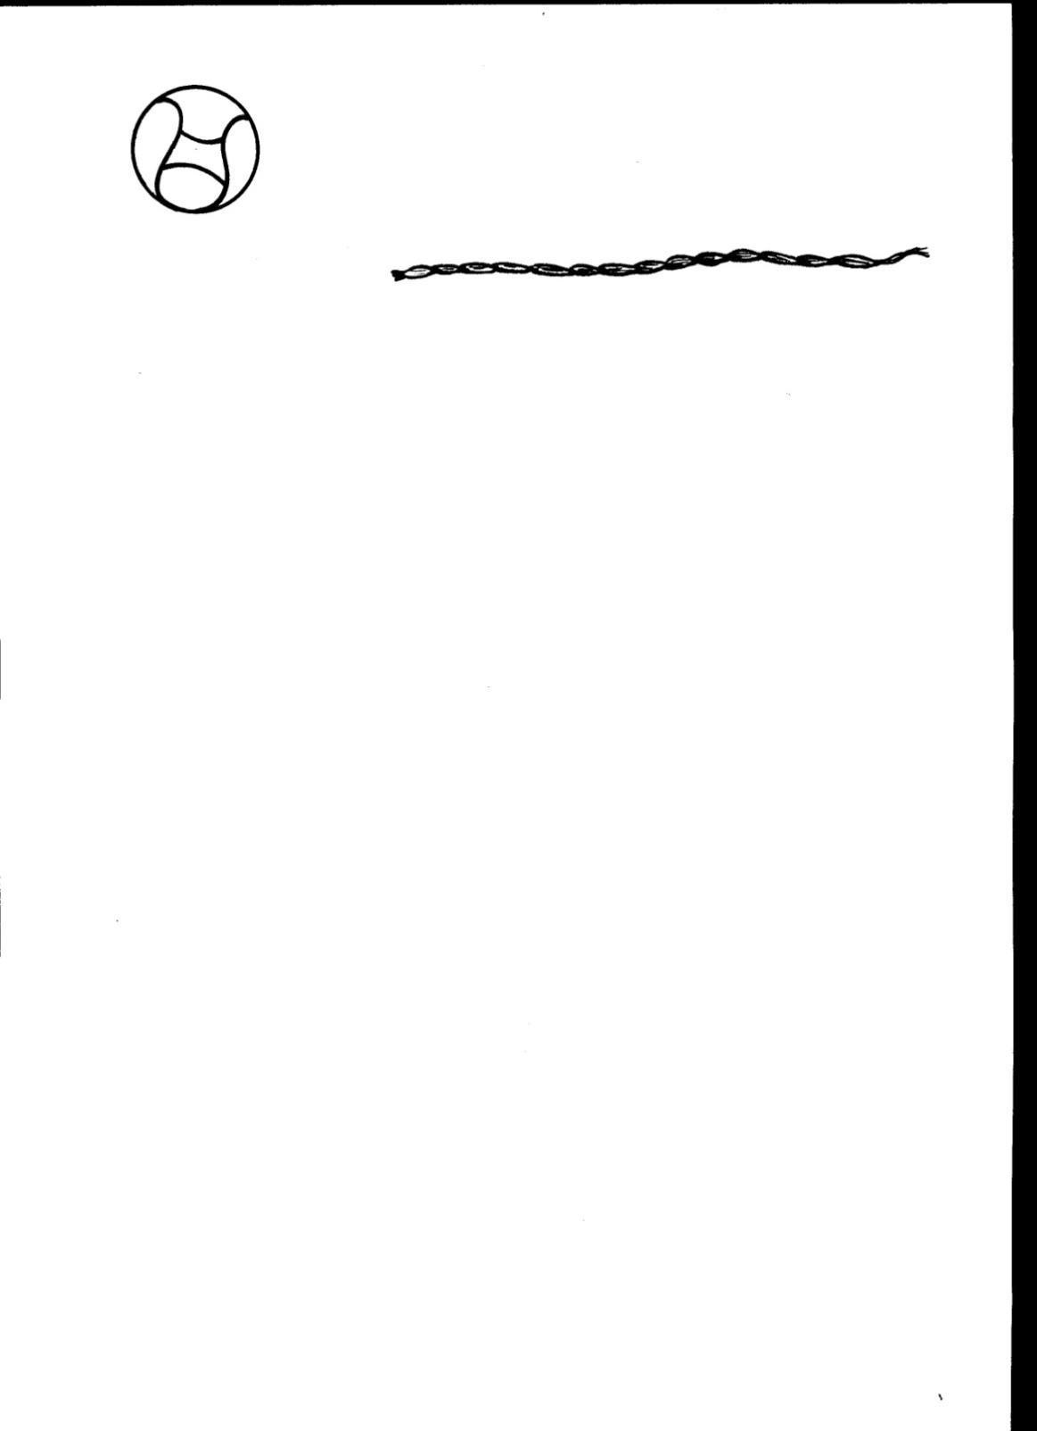  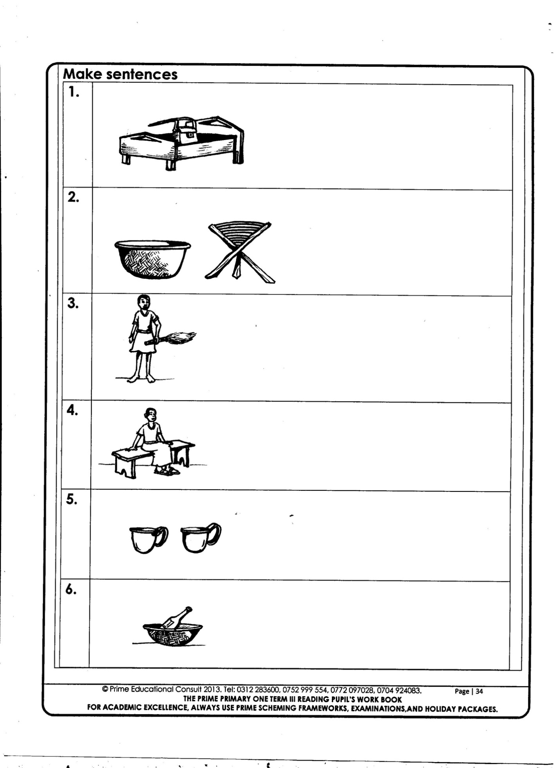  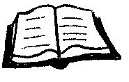  Given that A={ , , , , } and set B ={8, 6, 4, 2, 0}. Describe sets A and B.
2. | If set W={letter 8, 9, 6, 5, 3} and  X ={p, k, f, t}. What is the relationship between the two sets? | 3. | Given the sets below.  R  Q  P  3  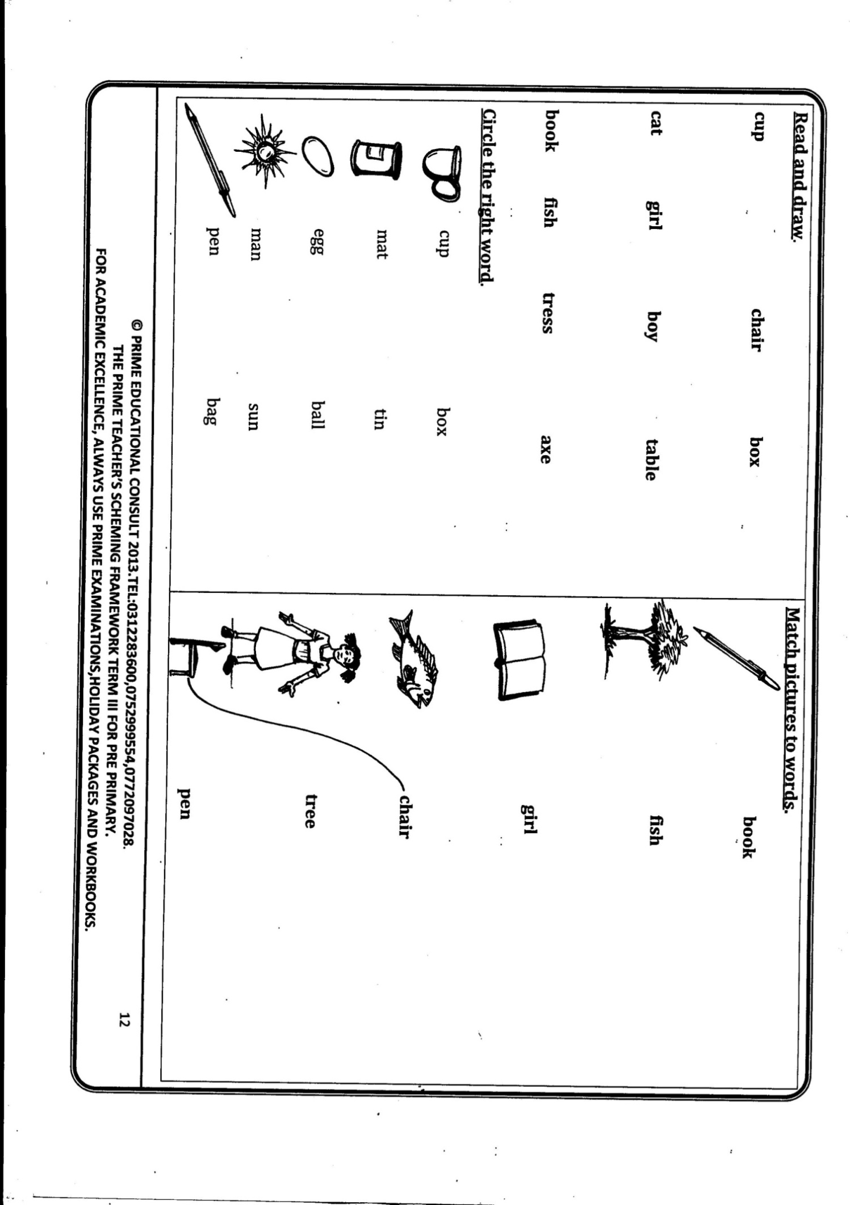  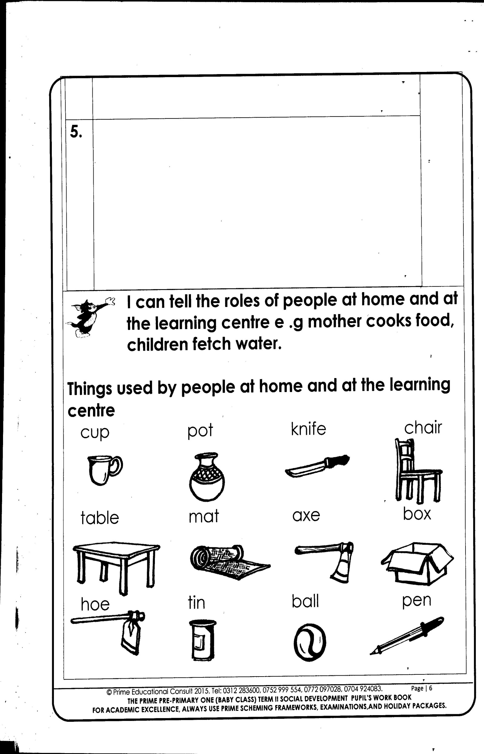  1  8  5  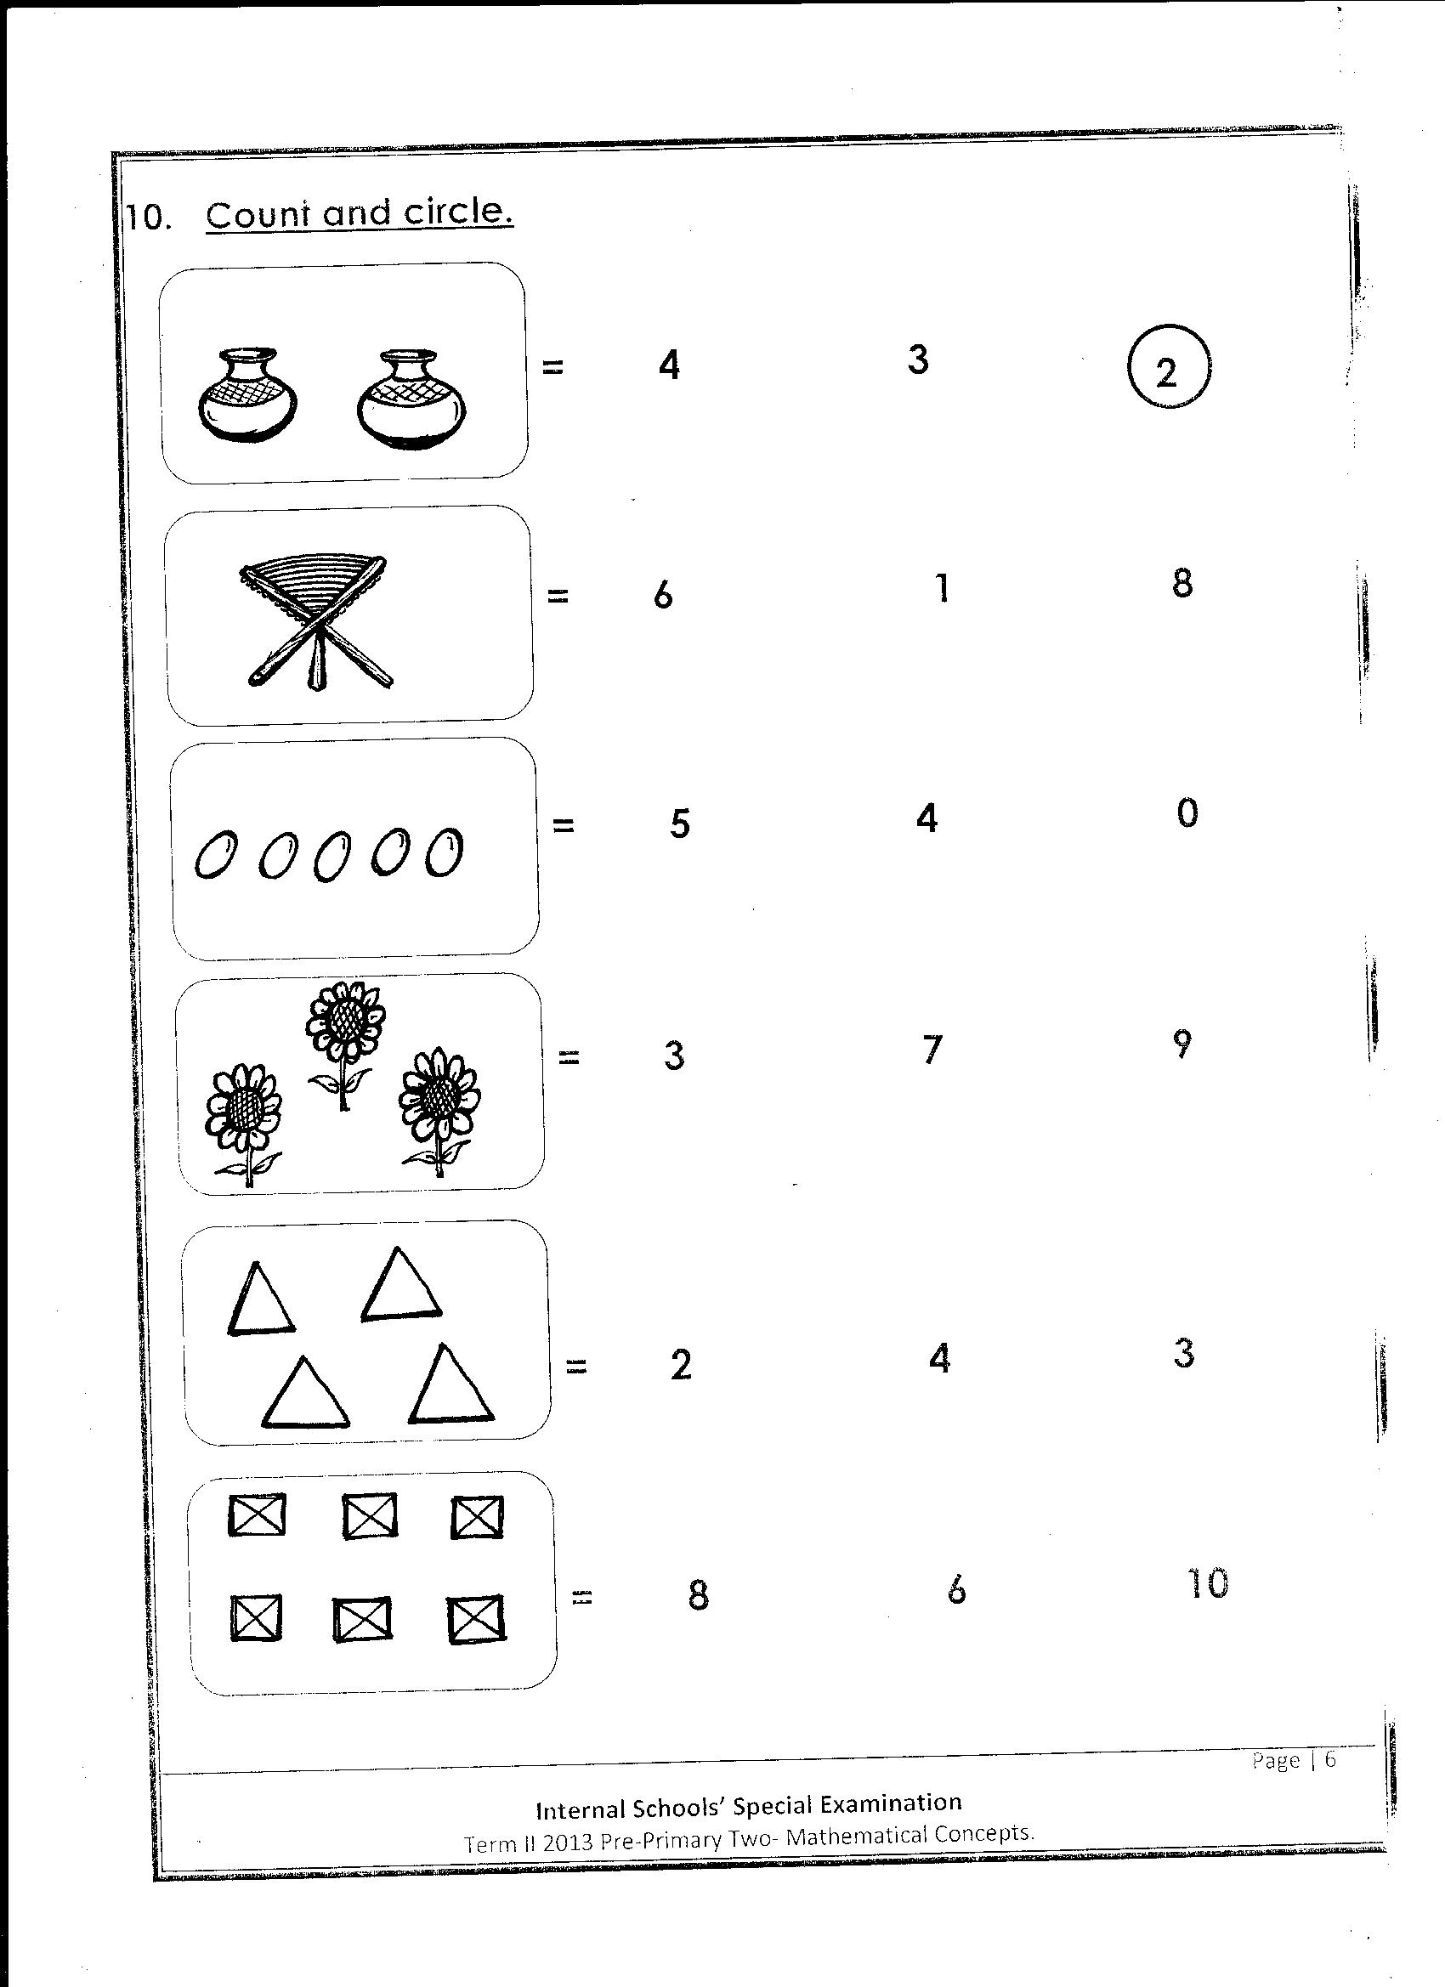  4  a) List elements of set Q
 | b) describe the following sets.  i) P and R  ________________________________  ii) Q and P  ________________________________  iii) R and Q  ________________________________ | 4 | If n(E) = 12 elements and n(F) = 9  a) Describe the relationship between sets E and F.  b) How many elements are needed to make set E equivalent to F
5. | Set T = {3, e, k, w, 6} and set T is equivalent to set V. find n(V) | 6. | Given that P = {counting numbers between 4 and 13}. Write the members of X that make it equivalent to P.
Competence 2
Equal and un equal sets and empty sets.
Equal sets are sets with the same elements while un equal sets are sets with different elements.
 | Examples
1. | Set X = {3, 4, 5, 6, 7, 8} and Set Y = {8, 7, 6, 5, 4, 3}. Describe set X and set Y.  Set X = set Y or they are equal sets. | 2. | If set K = {first 6 odd numbers} and set L = {first 6 whole numbers}  a) List set K and L.  K ={1, 3, 5, 7, 9, 11} and set L = {0, 1, 2, 3, 4, 5}
 | b) Describe the relationship between set K and set L.  n(K) = 6  n(L) = 6  set K and set L are_______________  set | 3. | Given that B = {boys with 4 legs each}  a) Describe set B  _______________________________  a) Find n(B)  _______________________________
 | Mega activity
1. | Set C = {k, d, e, m, w., r, y}, O = {n, x, f, a, b, k, n} and E = {w, r, e, m, d, w, k, y}  i) C and D.  ii) E and D  iii) C and E | 2. | Using =, =, compare the following sets  a) K = { } L = {3, f, q, e}  }  b) G = {2, 4, 6, 8, 10, 12, 14} set H = {14, 2, 2, 10, 12, 68}  c) n(P) = 3 __________ n(Q) = 10
3. | If set N ={whole numbers from 4 to 13} and set W ={counting numbers between 3 and 14}. What is the relationship between the two sets. | 4. | Set M = set N = {5, 6, 7, 8, 9, 10, 11}  a) List set M  b) Find n(N)
 | Competence 3
Listing and finding number of elements in the intersection sets.
Here we observe and identify ‘’common elements’’ from the given sets.
 | Examples
1. | Given that set A = {1, 2, 3, 4, 5, 6} and B = {9, 14, 12, 3, 6, 13}  a) List set AnB  (AnB) = {3, 6, 4}  b) Find n(AnB)  n(AnB) = 3 | 2. | Set D = {even numbers from 8 to 18} and set E ={counting numbers from 9 to 18}.  a) List set D and set B  D = { 8, 12, 14, 16, 18} E = {9, 10, 11, 12, 13, 14, 15, 16, 17, 18}  b) Find n(DnE)  = {10, 12, 14, 16, 18}  5 elements.
 | Practice activity.
1. | Set D = { , } and set F = { 8, 7, , } List set D intersection F. find DnF
2.  3. | Below is a venn diagram  Y  X  m  e  c  k  b  a  f  n  h  L  d  j  a) Describe set X and set Y  b) List set (XnY)  Given that set P = {9, 8, 7, 3} and set K = {1. 2, 3, 6, 8} |  | c) Find n(X)  d) List all the members of set Y.
LESSON 2
Describing Union sets
Union set is the set of all elements
Key learning principle
When listing a union set, we first identify the common elements and we write them once. When listing elements, we list then in carty brackets and put a comma every after the element.
 | Examples
1. | Given that set P ={1, 2, 3, 4, 5} and set Q = {0, 2, 4, 6, 8}. Find PUQ  PUQ = {2, 4, 1, 3, 5, 0, 6, 8} | 2. | Given that set X {a, e, I, o u} and set Y ={a, b, c, d, e} List set XUY. XUY = {a, e, b, c, d, I o, u}
3. | Given that set T = {1, 2, 3, 4,} and Q = {1, 3, 5, 7}.  a) Find TUQ  Set TUQ ={1, 3, 5, 7, 4} |  | b) How many elements are in set TUQ?  There are 5 elements.
 | Practice activity
1. | In the space below, draw a symbol for empty set. | 2. | Write Empty set or Not empty set.  a) A = {cars that have 4 tyres each }  __________________________________  b) M = {All vowel}  ________________________________
 | c) A set of brooms used for sweeping  ________________________________ |  | d) B = {cows that produce water}  __________________________________
4.  5. | Given that set A = {cow, goat, sheep} and set B = {dog, cow, sheep} find set AUB.  Given that set M = {6, 8, 9, 10, 12} and set P = {4, 5, 6, 7, 2, 9}. Find n(MUP)
Describing parts of a venn diagram
The venn diagrams are formed by two overlapping shapes.
Key learning principle
Study the sets A and B below.
A B

B only/ B - A

A U B

A n B
A only/ A - B

 | Examples 1
1. | Use a sharp pencil and shade the regions given below.  a) B n C  C  B |  | b) MUK  K  M
 | c) M only.  M  N |  | d) Set P  Q  P
2. | Describe the unshaded region below.  Y  X  a) |  | 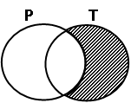  b)
 | c)  K  L |  | d)  J  P
 | Practice activity
1. | Shade the regions below.  a) A – B  A  B  E |  | b) T U V  X  T  Y
 | c) S n E  S |  | d) F only.  F
Interpreting information on a venn diagram
When interpreting information on a venn diagram, we consider the two sets.
 | Key learning principle
1. | Use the venn diagram below to answer questions that follow.  goat  Monkey  Cat  Dog  lion  Sheep  a) Find n(X) only.  n(X) only= {monkey, dog, sheep}  n (X) only = 3 |  | b) Find X U Y  X U Y = {monkey, dog, sheep, cat, goat, lion}  c) Find Y  Y = {cat, goat, lion)
 | Practice activity.
1. | Study the Venn diagram below and answer the questions that follow.  L  K  goat  Mouth  cat  Dog  lion  sheep  a) List all elements of set L. |  | b) What is KnL.  c) Find n(k)  d) Find (n(KUL)
Representing the given information on a venn diagram
Key learning principle.
When representing information on the venn diagram, we first identify the common elements and present them on a venn diagram and then consider other regions.

Examples
1. | Given that P = {5, 10, 15, 20}, B = {6, 7, 10, 15, 20, 25}. Represent the above information on the venn diagram below.  B  P  6  10  7  15  5  20  25 | 2. | If set C = {10, 20, 30, 40, 50} and W = {20, 25, 30, 35, 40}. Represent the above information on the venn diagram below.  W  30  20  25  40  10  50  35  C
 | Practice activity
1. | Given that E = {a, b, c, d, e} and S = {b, a, n, d, g}  a) Represent the above information on the venn diagram below.  E  S  b) Find n (EnS) |  | c) Find S – E  d) Find set E only.
2. | Give that set Z = {1, 2, 3, 4, 5, 6}, A = {3, 5, 7, 6, 9, 0}.  a) Represent the above information on the venn diagram.  Z  A
 | b) Find n(AnZ) |  | c) List all members of set A U Z.

